Monthly Ransomware Victims Report

# Sector Distribution

Technology: 9 vaka

Unknown: 16 vaka

Healthcare: 3 vaka

Manufacturing: 6 vaka

Construction: 2 vaka

Business Services: 1 vaka

Education: 1 vaka

Public Sector: 1 vaka

# Group Distribution

Kraken: 1 vaka

Arcusmedia: 2 vaka

Incransom: 10 vaka

Lynx: 2 vaka

Worldleaks: 7 vaka

Handala: 1 vaka

Qilin: 5 vaka

Securotrop: 1 vaka

Devman: 1 vaka

Kawa4096: 1 vaka

Direwolf: 4 vaka

Interlock: 3 vaka

Safepay: 1 vaka

# Country Distribution

Unknown: 4 vaka

United States: 23 vaka

Canada: 2 vaka

Germany: 1 vaka

Thailand: 1 vaka

Portugal: 1 vaka

Spain: 1 vaka

United Kingdom: 1 vaka

Chile: 1 vaka

Turkey: 2 vaka

Singapore: 2 vaka

# Continent Distribution

Unknown: 4 vaka

North America: 25 vaka

Europe: 4 vaka

Asia: 5 vaka

South America: 1 vaka

## Sector Distribution Chart

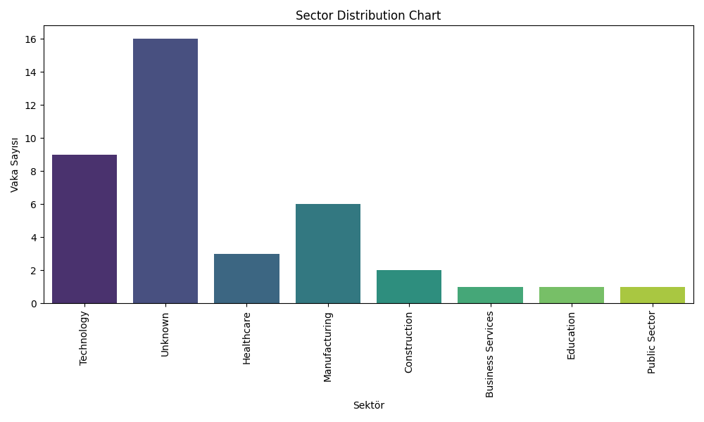

## Group Distribution Chart

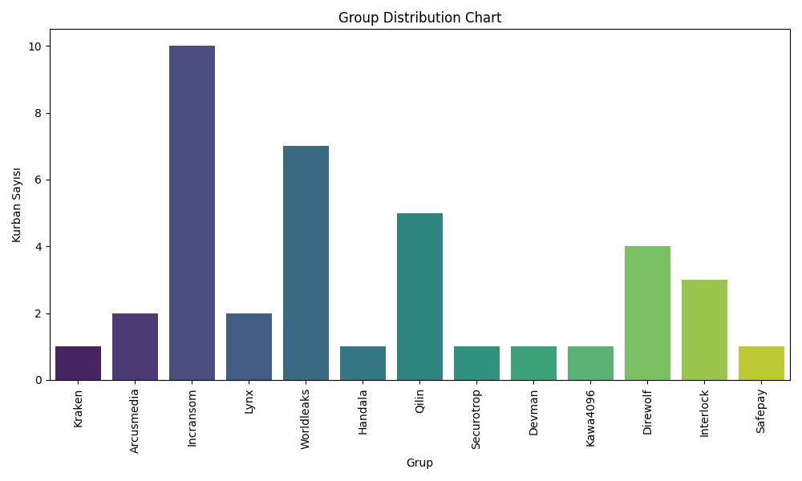

## Country Distribution Chart

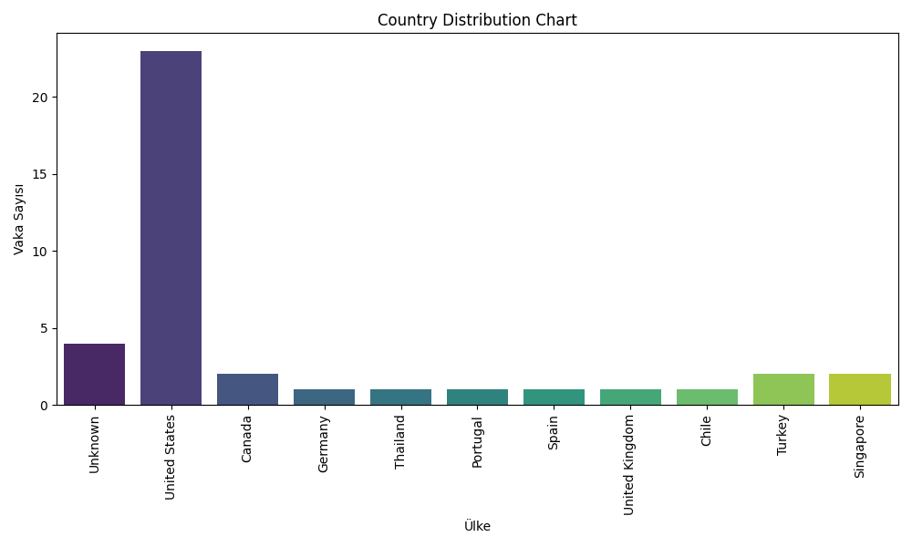

## Continent Distribution Chart

